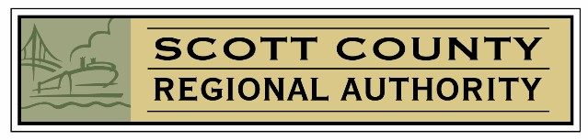
Dear Grant Applicant:

On behalf of the Scott County Regional Authority (“SCRA”), thank you for your interest in applying for funds for the upcoming grant cycle. This Grant Application outlines the information that must be provided in order to be considered for funding as well as limitations on the type of projects eligible for SCRA consideration. Please read the material carefully and follow the funding criteria and instructions for submitting grants as failure to comply may result in your grant request not being submitted for consideration.

SCRA only accepts grant applications from qualified organizations located in the Quad City community that directly serve residents of Scott County, Iowa.

While the SCRA attempts to fund as many projects as possible, the dollars requested far exceed the amount of funds available for distribution. As less than two-thirds of grant requests typically receive funding, the submission of a grant does not and cannot guarantee funding.

Grants are considered by one of three panels: Government/Civic, Education and Non-Profit. Each distribution panel acts in a democratic fashion to rate the grant requests. Panel members consider:

- The nature and scope of a requested project,
- The effect such project will have on residents of Scott County,
- The availability of alternative means of funding a project, including matching dollar availability, ➢ The history of funding by the SCRA to the entity in question, and ➢ The size of the request.

This list is not intended to be exhaustive and the panel may consider other criteria in judging grant requests. The SCRA Board, consisting of a diverse group of Scott County residents, makes the final determination on whether funding will be approved.

Prior funding does not assure that future grants will also be approved. Panel members change from year-to-year, as do the needs within our community. Entities should not plan or budget that SCRA funds will be awarded. The SCRA may partially fund a grant request if the reviewing panel believes that a project can be completed for less money, or that other moneys are available in the community, or that available funds do not exist to fund other worthy grant requests.

Questions concerning the Grant Application process may be submitted to Karen at (563) 344-2626 or by e-mail at scraiowa@aol.com. Grant applicants should not lobby panel members. Additionally, the SCRA Board and panel members will not discuss with grant applicants the specific reasons why a grant was not funded.

Over the years, SCRA has funded many grant requests for school districts, government entities and nonprofit organizations. SCRA’s ability to continue to fund projects depends, in part, on the good stewardship of those receiving grant funds. It is not uncommon for the actual cost of purchases included in a grant request to be less than the amount requested in the grant. The SCRA will provide reimbursement only for the purchases included in the original grant request. We strongly encourage all applicants to seek bids prior to submitting the grant request where appropriate. Seeking bids and providing information about this process in the grant application will be taken into consideration in evaluating grant applications. In the event that a grant recipient desires additional products or services not included in the grant application budget, a new grant application should be submitted.

Thank you for your interest in a grant from the SCRA.

Sincerely,

Maegan Gorham, President

